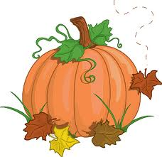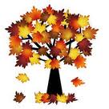

Assalmu Alaikum,

Greetings Crescent families!

We hope this letter finds you in the best of health and Iman. We are well into Unit 2 and students are demonstration daily the values and virtues of a noble character. Students are continuing to learn and master new concepts.

Unit 2 – Moral Literacy: Noble Character

Concepts: Energy, Values and Virtues, Opposites and Complements

**ANNOUNCEMENTS**

\***Stars of the Week:** Week of 11/15/13: Yusef Mallad, Aadam Ahmed, Calla Altaani**Takbeer to these students for showing positive attributes!

*No School Thursday and Friday 11/28, 11/29

*Students need to be dressed in warm clothing in order to enjoy recess. Please send proper coats, hats and gloves!

*Weebly pages should be reviewed by students and parents daily for updates and Home Study assignments.

**2nd Grade Newsletter**

**Unit 1 Week 5**

**ISLAMIC STUDIES**

We are currently studying the seerah of Prophet Mohammed (PBUH). We are studying important events within Prophet Mohammed’s (PBUH) life as well as the trials and tribulations he faced. We will learn about his role as a peacemaker, and a source of truth for his community. It is our hope that students develop a love for Rasull-Allah, as well as to become inspired by his noble actions. Please assist us in our journey by providing our students with any extra seerah books and storytelling regarding our beloved Prophet Mohammed (PBUH). Jazakum Allahu Khairan!

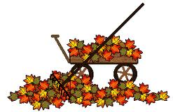

**SOCIAL STUDIES**

We will spend our time learning about famous Noble Characters from past to present. Students will learn what characteristics define a noble character. We will have a plethora of reading and visual materials to help us research these people and students will create a time line of their life and of a noble character’s life as a culminating project. Students have begun gathering information for the first step of this project, a personal time line.

**SCIENCE**

We are moving on from force and magnetism to expand our knowledge of simple machines. The students are enjoying the multiple experiments we have designed for their learning. We are working to learn the scientific method during these explorations, in order to form more concrete science skills.

**MATH**

Students are continuing to progress in their ability to calculate elapsed time. This is a skill that could be easily practiced at home. We are continuing to practice model drawing to solve word problems. Next unit we will learn to count and calculate money.

**LANGUAGE ARTS**

Reader’s Workshop: Students are working hard during their language centers each week. Students spend time in Book Clubs with the teacher, reading to self, reading to others, working on writing and working on their word knowledge.

Writer’s Workshop: We have worked with our revising and editing partners to get our stories ready to publish. We will begin publishing our second writer’s workshop story next week!