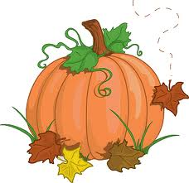

Assalmu Alaikum,

Greetings Crescent families!

We hope this letter finds you in the best of health and Iman. We are well into Unit 2 and students are demonstration daily the values and virtues of a noble character. Students are continuing to learn and master new concepts.

Unit 2 – Moral Literacy: Noble Character

Concepts: Energy, Values and Virtues, Opposites and Complements

**ANNOUNCEMENTS**

\***Stars of the Week:** Week of 10/21/13: Fiza Ali, Reem Suleiman, Rani Ahmad **Takbeer to these students for showing positive attributes!

*No School Tuesday Nov. 5, teacher in-service

*Students need to be dressed in warm clothing in order to enjoy recess. Please send proper coats, hats and gloves!

*Weebly pages should be reviewed by students and parents daily for updates and Home Study assignments.

**2nd Grade Newsletter**

**Unit 1 Week 5**

**ISLAMIC STUDIES**

We are currently studying the seerah of Prophet Mohammed (PBUH). We are studying important events within Prophet Mohammed’s (PBUH) life as well as the trials and tribulations he faced. We will learn about his role as a peacemaker, and a source of truth for his community. It is our hope that students develop a love for Rasull-Allah, as well as to become inspired by his noble actions. Please assist us in our journey by providing our students with any extra seerah books and storytelling regarding our beloved Prophet Mohammed (PBUH). Jazakum Allahu Khairan!

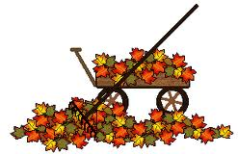

**SOCIAL STUDIES**

We will spend our time learning about famous Noble Characters from past to present. Students will learn what characteristics define a noble character. We will have a plethora of reading and visual materials to help us research these people and students will create a time line of their life and of a noble character’s life as a culminating project. Students have begun gathering information for the first step of this project, a personal time line.

**SCIENCE**

We have begun to explore force and magnetism. The students are enjoying the multiple experiments we have designed for their learning. We are working to learn the scientific method during these explorations, in order to form more concrete science skills.

**MATH**

Students have worked hard to master multi-digit addition, subtraction and place value. Next week we will be moving on to explore telling time and elapsed time. We are continuing to practice solving problems using model drawing for both basic facts and word problems.

**LANGUAGE ARTS**

Reader’s Workshop: We have begun daily language arts centers that focus around small group learning of reading, writing and word study. Students spend time in Book Clubs with the teacher, reading to self, reading to others, working on writing and working on their word knowledge.

Writer’s Workshop: We are continuing personal narratives this unit. Students are working to develop small moment “Seed’ stories, and focus their writing to add details to one small personal experience. We will also have a strong focus on revision and editing skills and will begin publishing a final story in a few weeks.