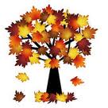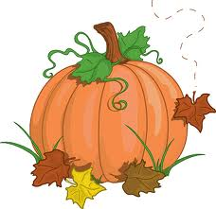

Assalmu Alaikum,

Greetings Crescent families!

We hope this letter finds you in the best of health and Iman. We are currently wrapping up our first unit of Spiritual Literacy. Insha’Allah, students will be working on their culminating activity this week as well as visiting the Cranbrook Museum. This is a wonderful group of students and we are looking forward to an excellent week, insha’Allah.

Unit 1 – Spiritual Literacy : God Consciousness

Concepts: Systems, Oneness, Wholeness, Unity and Diversity

**ANNOUNCEMENTS**

*Cranbrook Science Center Field Trip: Thursday Oct. 3. Our bus should pick us up around 9am and insha’Allah, have us back before 3pm. Please be sure to pack lunch in paper/plastic bags.

*Author’s Celebration will be Friday at 10am. Please come by and listen to our stories. Also, please be sure that all snacks are free of nuts and sesame seeds. Thank you very much!

*Hot lunch is served on Tuesday, Wednesday and Thursday for $4.00.

*Weebly pages should be reviewed by students and parents daily for updates and Home Study assignments.

**2nd Grade Newsletter**

**Unit 1 Week 6**

**ISLAMIC STUDIES**

We will focus on the story of Musa (AS) and the obstacles he faced. We will reflect on miracles Musa (AS) was able to perform by the Will of Allah (SWT). Students will learn that these miracles were performed in order to increase faith within the people. Allah (SWT) sent messengers to mankind in order to raise God-consciousness. “We make no distinction between one and another of His messengers”(2;285). Insha’Allah, we will then move into the life of Allah’s (SWT) final messenger Mohammed (PBUH). Insha’Allah, we will develop taqwa (piety) as we reflect on the history of Prophethood.

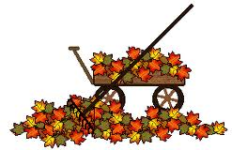

**SOCIAL STUDIES**

This unit, students will be learning about the communities they are a part of (family, school, religious, town, etc.) and the different aspects that make a community work as a system. We will also discuss the differences between wants and needs and how that affects us personally and as a community.

**SCIENCE**

This week students will begin working on their culminating activity. Students will construct their own solar system on poster boards. Students will be given step by step directions as well as materials to perform this task. Students will be expected to portray all of the planets in order from Mercury to Neptune.

Insha’Allah, we will also be visiting the Cranbrook Museum this Thursday in order to study within their planetarium. We will also take part in a magnetism show which will be great for our next unit, insha’Allah. Students are expected to dress in uniform and pack lunch in paper bags. Students may bring extra money for the gift shop. Thank you!

**MATH**

Students are continuing their work with numbers in expanded form. We are reviewing place value as well as addition and subtraction. We are comparing the values of numbers by practicing with inequalities (greater than, less than, and equal too). We are also practicing solving problems using model drawing for both basic facts and word problems.

**LANGUAGE ARTS**

Reader’s Workshop: We have begun daily language arts centers that focus around small group learning of reading, writing and word study. Students spend time in Book Clubs with the teacher, reading to self, reading to others, working on writing and working on their word knowledge.

Writer’s Workshop: Students are currently crafting their first published piece. Their stories are wonderful and we would love to invite all parents to our first Author’s Celebration this Friday morning, insha’Allah. We plan to begin at 8:30am and end at 9:30am. Please support us by sending in healthy snacks as well. Snacks must be nut free and healthy as well. Jazakum Allahu Khairan for all of your support!