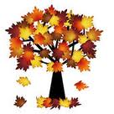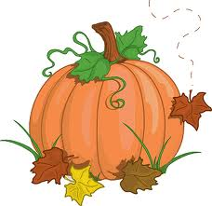

Assalmu Alaikum,

Greetings Crescent families!

We hope this letter finds you in the best of health and Iman. We are off to a great start in 2nd grade. Students are hard to working and doing an excellent job falling into the classroom procedures and expectations. This is a wonderful group of students and we are going to have a great year full of expanded our knowledge and become stewards.

Unit 1 – Spiritual Literacy : God Consciousness

Concepts: Systems, Oneness, Wholeness, Unity and Diversity

**ANNOUNCEMENTS**

\***Stars of the Week:** Week of 9/9/13: Sarim Hasan, Rayyan Shwehdi, Areebah Khan

Week of 9/16/13: Nia Ahmad, Junaid Raza, Haiqa Tanveer Takbeer to these students for showing positive attributes!

*Cranbrook Science Center Field Trip: Thursday Oct. 3. Permission slips and money is due!

*Picture Day: Oct. 1 (School Uniform)

*Hot lunch is served on Tuesday, Wednesday and Thursday for $4.00.

*Weebly pages should be reviewed by students and parents daily for updates and Home Study assignments.

**2nd Grade Newsletter**

**Unit 1 Week 5**

**ISLAMIC STUDIES**

We will begin reviewing the beginning of creation and the story of Adam (AS). Students will learn the significance of obeying the commands of Allah (SWT) and refraining from the whispers of the shayateen. We will also review and reflect on the stories of Prophets Nuh (AS) and Ibrahim (AS). Insha’Allah, we will develop taqwa (piety) as we reflect on the history of Prophethood.

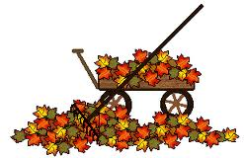

**SOCIAL STUDIES**

This unit, students will be learning about the communities they are a part of (family, school, religious, town, etc.) and the different aspects that make a community work as a system. We will also discuss the differences between wants and needs and how that affects us personally and as a community.

**SCIENCE**

This unit leads itself to an exploration of the solar system. We will be learning about the solar and lunar patterns, the planets, revolution and rotation. Also, we will be exploring moon phases as well other components of our solar system. Students will be guided to ponder on the various creations and recognize the blessings of Allah (swt). We are getting ready to begin the Solar System project. Look for information coming home soon.

**MATH**

As we expand our knowledge of addition and subtraction we will begin to study numbers in expanded form and how we use it addition. We will also begin practicing with inequalities (greater than, less than, and equal too). We are also practicing solving problems using model drawing for both basic facts and word problems.

**LANGUAGE ARTS**

Reader’s Workshop: We have begun daily language arts centers that focus around small group learning of reading, writing and word study. Students spend time in Book Clubs with the teacher, reading to self, reading to others, working on writing and working on their word knowledge.

Writer’s Workshop: Students have started filling their writing folders with “Writing From Experience” pieces. Writing about what they have already experienced makes the writing process move more fluidly. We are ready to pick a piece to publish and will begin revising and editing a final copy to share in our first Writer’s Workshop Celebration!