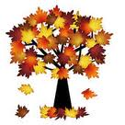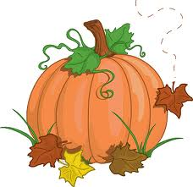

Assalmu Alaikum,

Greetings Crescent families!

We hope this letter finds you in the best of health and Iman. We have completed our first unit and are beginning unit 2 this Monday. Students are continuing to learn and master new concepts.

Unit 2 – Moral Literacy: Noble Character

Concepts: Energy, Values and Virtues, Opposites and Complements

**ANNOUNCEMENTS**

\***Stars of the Week:** Week of 9/30/13: Louna Nassar, Safiy Syed, Lana Houmani **Takbeer to these students for showing positive attributes!

*Hajj Assembly Thusday 10/9 Please send Hajj clothing: Boys: 2 white towels and safety pins (large) Girls: White Prayer clothing

*No School Mon 10/14-Thursday 10/17

*School-wide Eid celebration Friday 10/18, please return High Velocity permission slip and waiver!

*Weebly pages should be reviewed by students and parents daily for updates and Home Study assignments.

**2nd Grade Newsletter**

**Unit 1 Week 5**

**ISLAMIC STUDIES**

We will begin studying the significance of the blessed days of Dhul Hijjah as well as the Hajj. Students will learn the value of these first 10 days of Dhul Hijjah. Ibn 'Abbas reports that the Messenger of Allah (sallallahu alayhi wa sallam) said, "No good deeds done on other days are superior to those done on these days [meaning the ten days of Dhul Hijjah]." Insha’Allah, students will also take place in the Hajj Assembly. Please help us in making sure that all boys come to school with two white towels and two large safety pins and all girls come to school with a full prayer outfit (top and bottom) by next week on Tuesday, October 8th, 2013. These should be stored in a marked plastic bag.

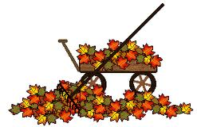

**SOCIAL STUDIES**

We will spend our time learning about famous Noble Characters from past to present. Students will learn what characteristics define a noble character. We will have a plethora of reading and visual materials to help us research these people and students will create a time line of their life and of a noble character’s life as a culminating project.

**SCIENCE**

The Cranbrook field trip provided students with a chance to start learning about magnetism, our main concept for this unit. Students will complete many experiments to learn about this impressive force. Students will use their prior knowledge of magnetism on Earth to expand their learning.

**MATH**

As we expand our knowledge of addition and subtraction we will begin to study numbers in expanded form and how we use it addition and subtraction. Students will discover how adding and subtracting is an opposite and complimenting function. We are continuing to practice solving problems using model drawing for both basic facts and word problems.

**LANGUAGE ARTS**

Reader’s Workshop: We have begun daily language arts centers that focus around small group learning of reading, writing and word study. Students spend time in Book Clubs with the teacher, reading to self, reading to others, working on writing and working on their word knowledge.

Writer’s Workshop: Thank you to the hard work of the students and the donations of their families for a wonderful first celebration of Writer’s Workshop! This unit we will begin with writing letters, an important piece of this year’s Children of Charity Project.